**Mario Craft**

**Phase 3**

**Student:** Suki Tsz Ki Chan

**Group:**  Group GD2

**Submission Date: 08/12/2016**

Table of Contents

**Introduction** 3

**Tools Used** 4

**GitHub** 4

**Main Menu Form** 5

**Register Form** 9

**User Account** 13

**Conclusion** 17

**References** 18

# **Introduction**

This is an individual project continuing from phase 1 and phase 2 of the project. In this phase of the project, I am to implement MarioCraft by creating a graphical user interface. The language I used to code was C#. I created Main Menu, Register Menu and User Account Menu.

Main Menu UI

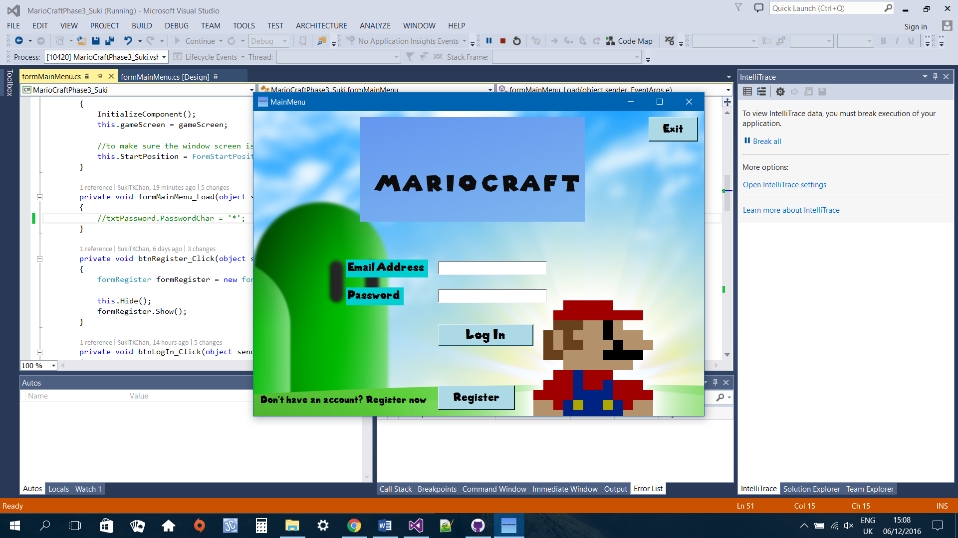

Register Menu

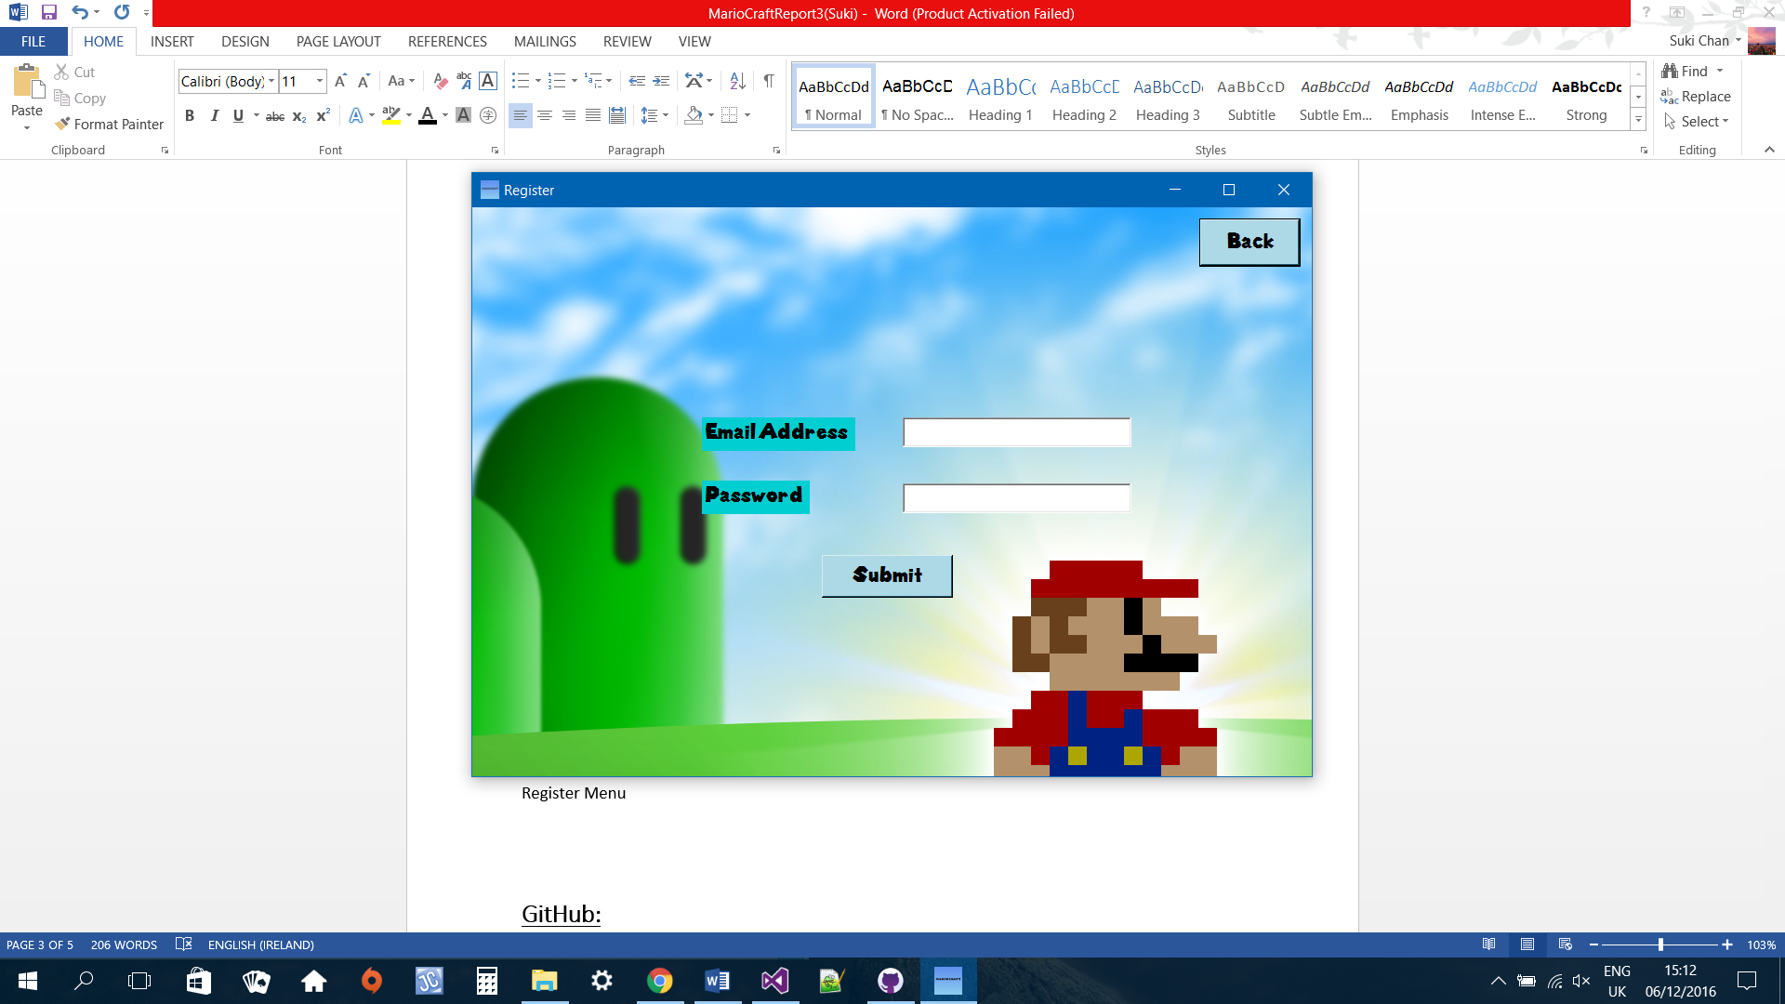

User Account

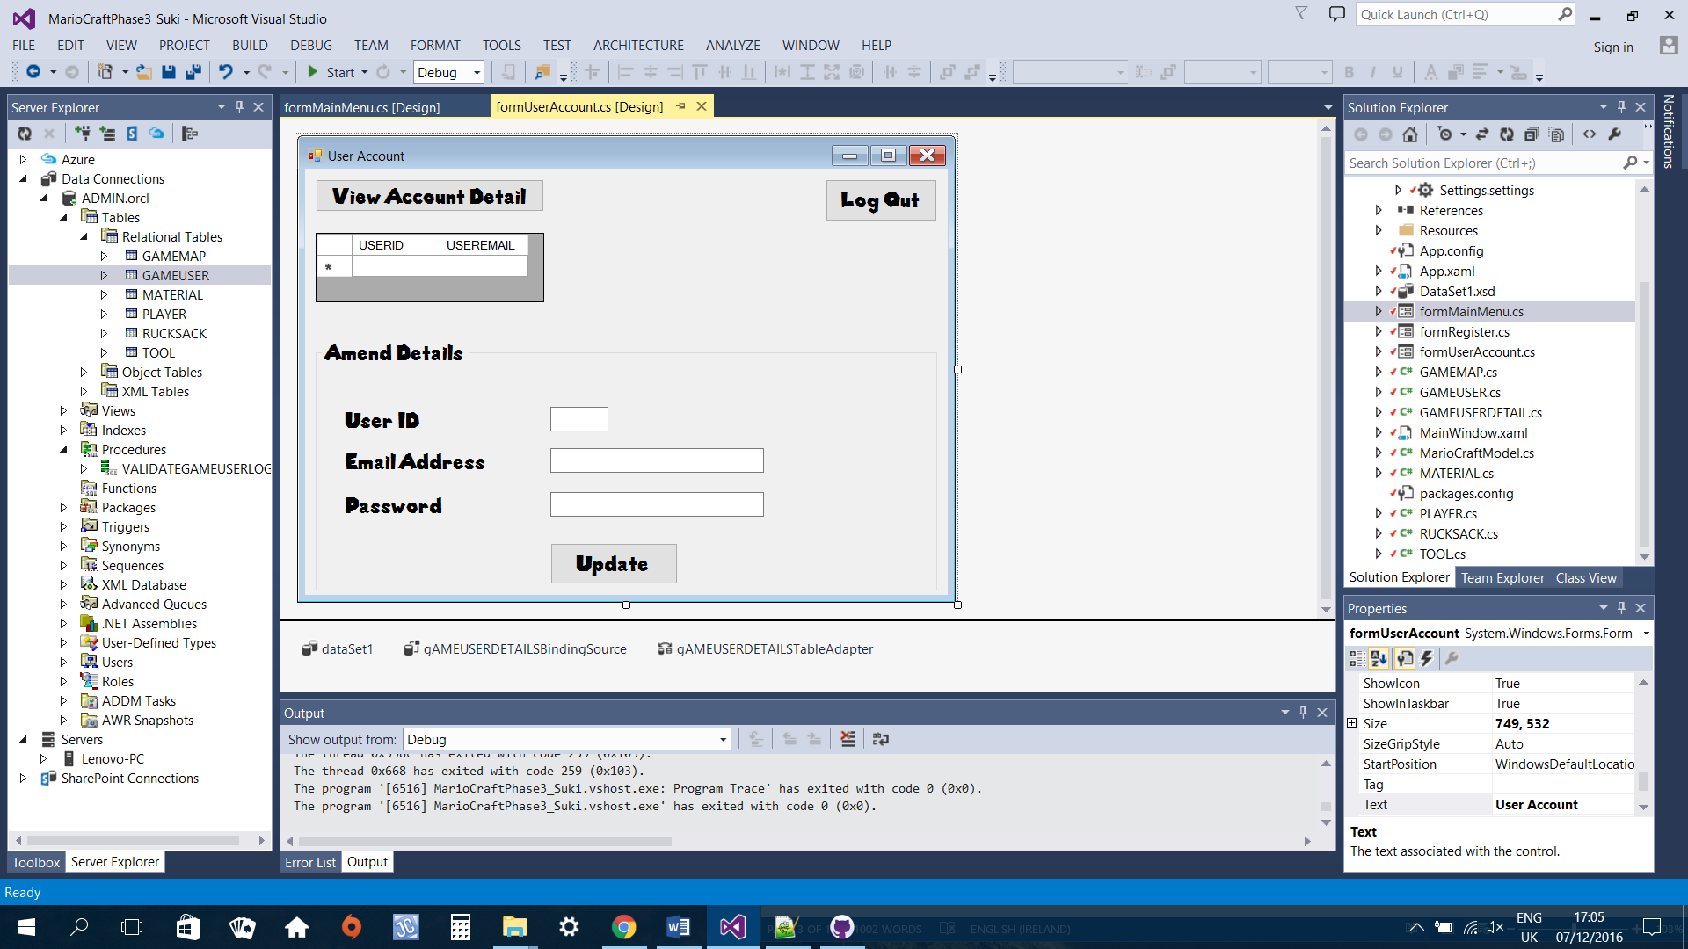

# **Tools Used**

Visual Studio 2013

Entity Framework

GitHub: <https://github.com/SukiTKChan/MarioCraftPhase3>

# **GitHub**

I am using GitHub for version control. I find this convenient and efficient as I can keep track what changes I have made.

Screenshot of commit messages

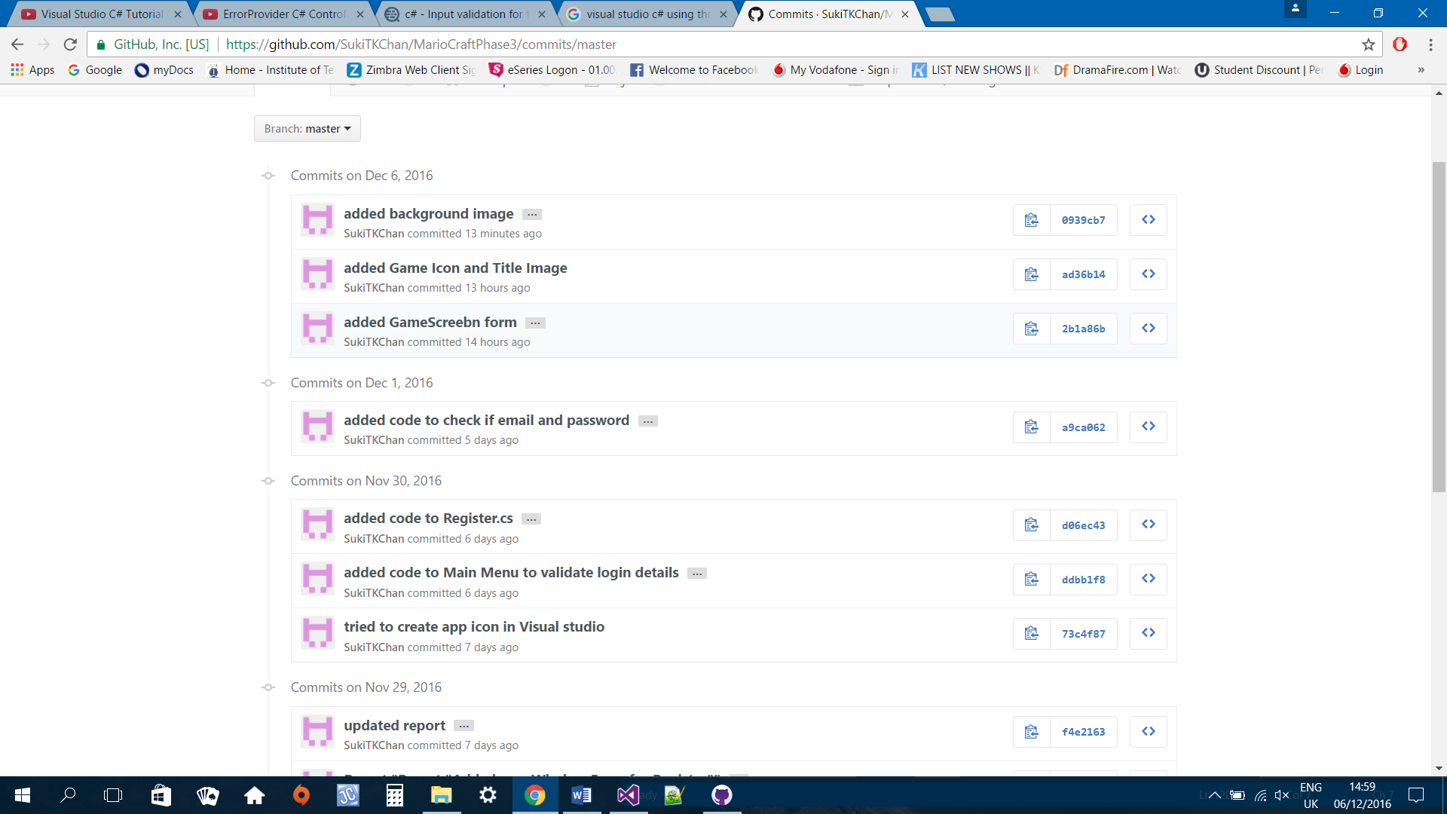

# **Main Menu Form**

The main menu form is the first screen that will display when the program runs. Every game user must either log in or register an account in order to play. If the game user does not have an account, he/she will need to click on the register button and the register menu will display. Otherwise, the user will need to enter an email address and password. The system will then validate to make sure the email and password input matches database.

## **formMainMenu Code:**

using System;

using System.Collections.Generic;

using System.ComponentModel;

using System.Data;

using System.Drawing;

using System.Linq;

using System.Text;

using System.Threading.Tasks;

using System.Windows.Forms;

using System.Data.OracleClient;

namespace MarioCraftPhase3_Suki

{

public partial class formMainMenu : Form

{

private formRegister registerMenu;

private formUserAccount gameScreen;

GAMEUSER gameUser = new GAMEUSER();

public formMainMenu()

{

InitializeComponent();

//to make sure the window screen is display at centre

this.StartPosition = FormStartPosition.CenterScreen;

}

public formMainMenu(formRegister registerMenu)

{

InitializeComponent();

this.registerMenu = registerMenu;

//to make sure the window screen is display at centre

this.StartPosition = FormStartPosition.CenterScreen;

}

public formMainMenu(formUserAccount gameScreen)

{

InitializeComponent();

this.gameScreen = gameScreen;

//to make sure the window screen is display at centre

this.StartPosition = FormStartPosition.CenterScreen;

}

private void formMainMenu_Load(object sender, EventArgs e)

{

//txtPassword.PasswordChar = '*';

}

private void btnRegister_Click(object sender, EventArgs e)

{

formRegister formRegister = new formRegister(this);

this.Hide();

formRegister.Show();

}

private void btnLogIn_Click(object sender, EventArgs e)

{

MarioCraftModel ctx = new MarioCraftModel();

//gameUser = ctx.GAMEUSERs.First();

var user = from u in ctx.GAMEUSERs where u.USEREMAIL == txtEmail.Text select u;

//var gu = from u in ctx.GAMEUSERs where u.USERPASSWORD == txtPassword.Text select u;

//if either email or password field empty display error message

if (txtEmail.Text.Equals("") && txtPassword.Text.Equals(""))

{

MessageBox.Show("Email and Password field cannot be empty", "Email or Password field empty",

MessageBoxButtons.OK, MessageBoxIcon.Error);

txtEmail.Focus();

return;

}

//https://dotprogramming.blogspot.com/2015/09/login-form-using-entity-framework-in.html

//check if user email matches database

var userExist = user.FirstOrDefault(a => a.USEREMAIL.Equals(txtEmail.Text));

//if email does not match records in database

if (userExist != null)

{

//if password matches records in database

if (userExist.USERPASSWORD.Equals(txtPassword.Text))

{

MessageBox.Show("Log in success!", "Log In Confirmation",

MessageBoxButtons.OK, MessageBoxIcon.Information);

formUserAccount gameScreen = new formUserAccount(txtEmail.Text);

this.Close();

gameScreen.Show();

}

else

{

errorProvider1.SetError(txtPassword, "Password does not match record,please try again");

txtPassword.Focus();

return;

}

}

else

{

MessageBox.Show("Game user not found",

"Invalid Email address",

MessageBoxButtons.OK, MessageBoxIcon.Error);

txtEmail.Focus();

return;

}

}

private void btnExit_Click(object sender, EventArgs e)

{

Application.Exit();

}

}

}

Validations:

Empty fields

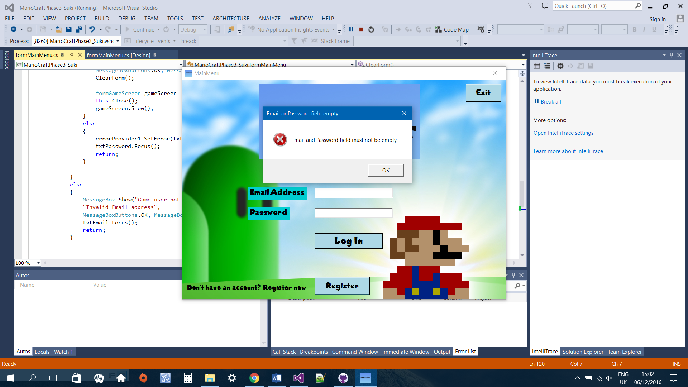

Email does not match database

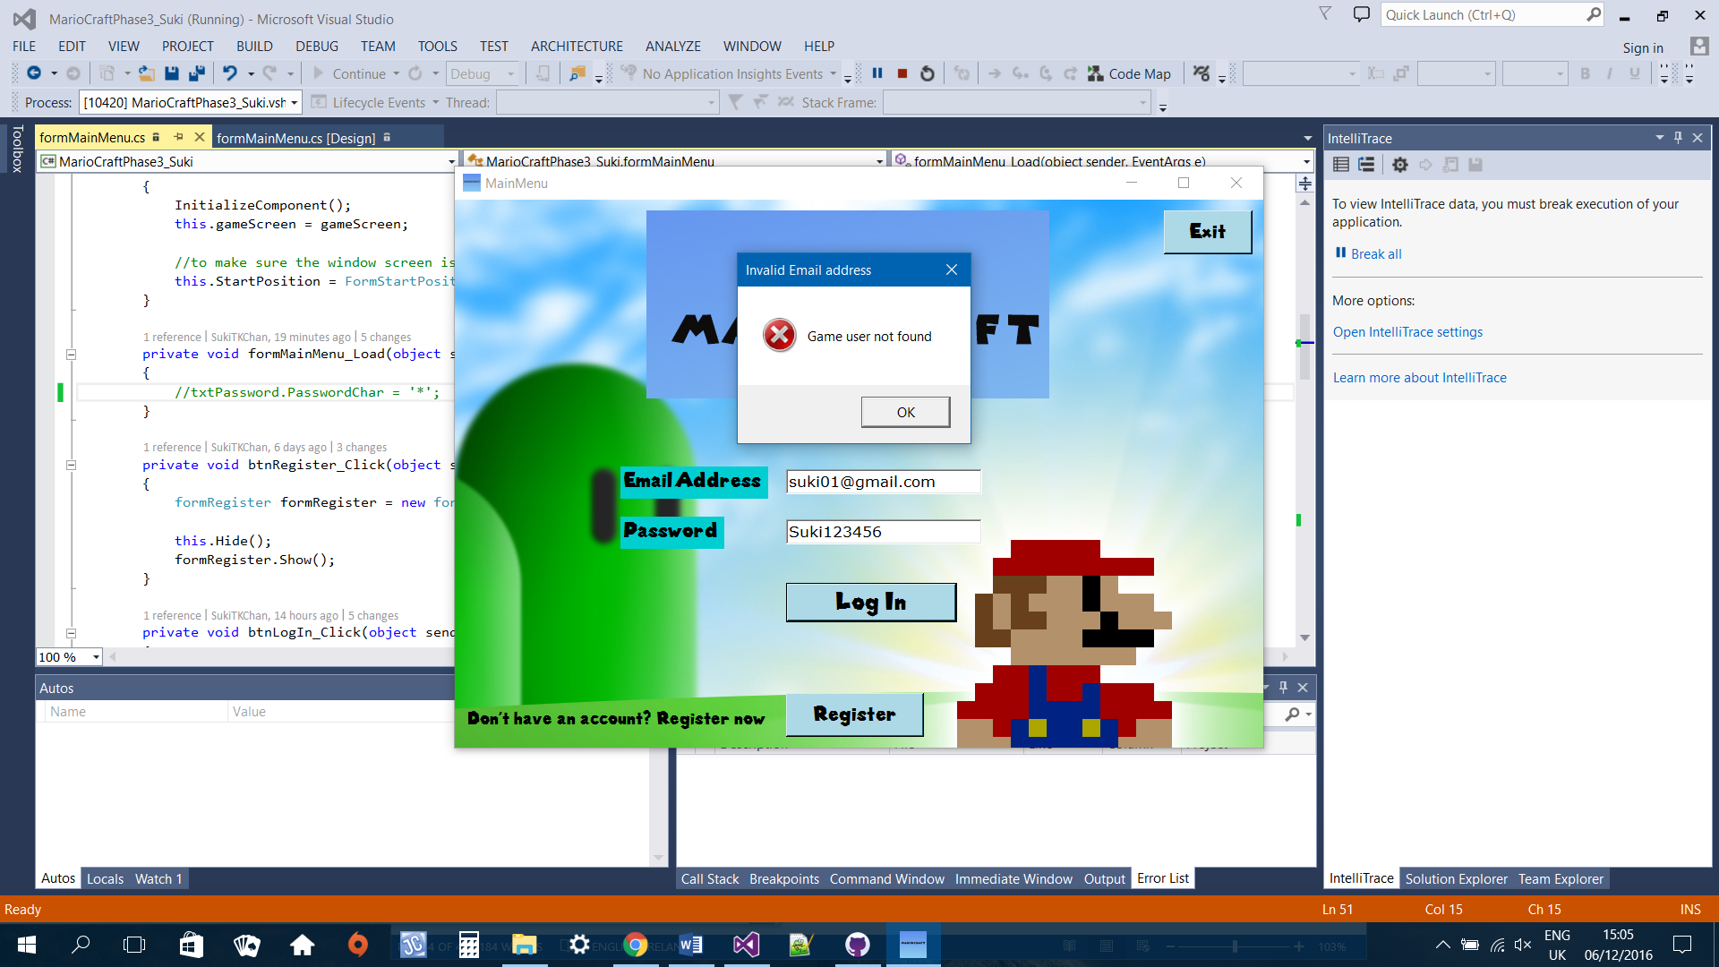

When valid email entered but password does not match database

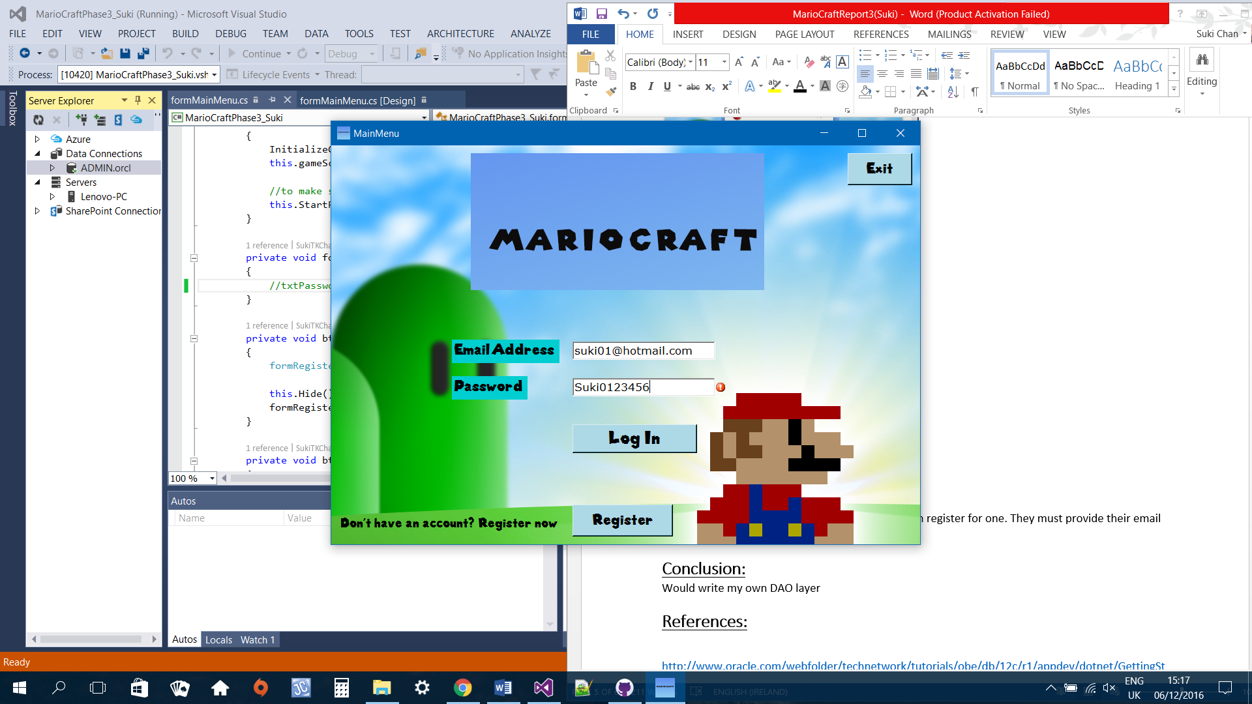

When both email and password matches database

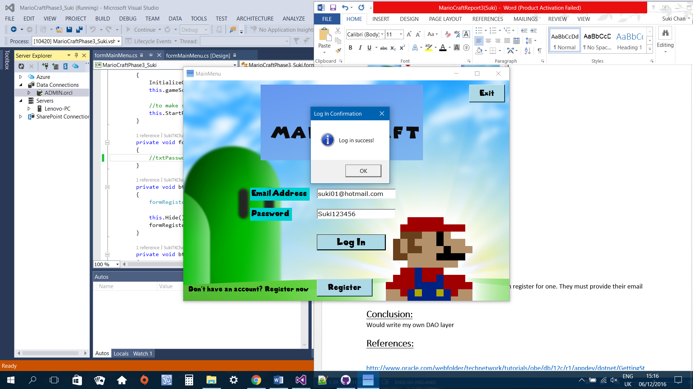

# **Register Form**

If the game user does not have an account, they can register for one. They must provide their email address and a password. The system will then check to make sure that the email enter does not already exists in the database because the constraint for email is it must be unique. If email matches database then the system will display the main menu where the game user can log in. Otherwise, the system will register the game user inserting email and password into database.

## **formRegister Code:**

using System;

using System.Collections.Generic;

using System.ComponentModel;

using System.Data;

using System.Drawing;

using System.Linq;

using System.Text;

using System.Threading.Tasks;

using System.Windows.Forms;

namespace MarioCraftPhase3_Suki

{

public partial class formRegister : Form

{

private formMainMenu mainMenu;

public formRegister()

{

InitializeComponent();

}

public formRegister(formMainMenu mainMenu)

{

InitializeComponent();

this.mainMenu = mainMenu;

this.StartPosition = FormStartPosition.CenterScreen;

}

private void formRegister_Load(object sender, EventArgs e)

{

toolTipEmail.SetToolTip(txtEmail, "Email address must contains @ ");

toolTipPassword.SetToolTip(txtPassword, "Password must be at between 6-20 characters in length " +

"\nMust must contain a number " +

"\nAn uppercase and a lowercase ");

}

private void btnBack_Click(object sender, EventArgs e)

{

formMainMenu mainMenu = new formMainMenu(this);

this.Close();

mainMenu.Show();

}

private void btnSubmit_Click(object sender, EventArgs e)

{

MarioCraftModel ctx = new MarioCraftModel();

GAMEUSER addGameUser = new GAMEUSER();

var user = from u in ctx.GAMEUSERs where u.USEREMAIL == txtEmail.Text select u;

//check if user email matches database

var userExist = user.FirstOrDefault(a => a.USEREMAIL.Equals(txtEmail.Text));

//if either email or password field empty display error message

if (txtEmail.Text.Equals("") && txtPassword.Text.Equals(""))

{

MessageBox.Show("Email and Password field must not be empty", "Email or Password field empty",

MessageBoxButtons.OK, MessageBoxIcon.Error);

txtEmail.Focus();

return;

}

//if email matches records in database

if (userExist != null)

{

//if password matches records in database

if (userExist.USERPASSWORD.Equals(txtPassword.Text))

{

MessageBox.Show("Game User already exist, please log in", "Registeration error",

MessageBoxButtons.OK, MessageBoxIcon.Error);

formMainMenu mainMenu = new formMainMenu(this);

this.Close();

mainMenu.Show();

}

}

else //insert user

{

using (var context = new MarioCraftModel())

{

addGameUser.USEREMAIL = txtEmail.Text;

addGameUser.USERPASSWORD = txtPassword.Text;

try

{

context.GAMEUSERs.Add(addGameUser);

context.SaveChanges();

MessageBox.Show(addGameUser.USEREMAIL + "\n" + addGameUser.USERPASSWORD + "\n" +

"You have Successfully Registered, Please log in", "Registered", MessageBoxButtons.OK, MessageBoxIcon.Information);

formMainMenu mainMenu = new formMainMenu(this);

this.Close();

mainMenu.Show();

ClearForm();

}

catch (Exception ex)

{

MessageBox.Show(ex.GetBaseException().ToString(), "Error", MessageBoxButtons.OK, MessageBoxIcon.Error);

}

}

}

}

private void ClearForm()

{

txtEmail.Clear();

txtPassword.Clear();

}

}

}

When email already exists

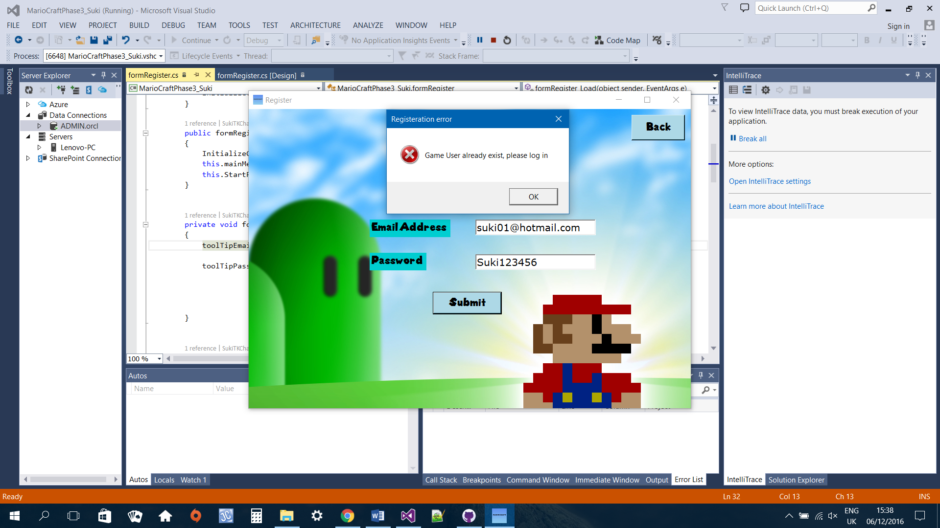

When both fields empty

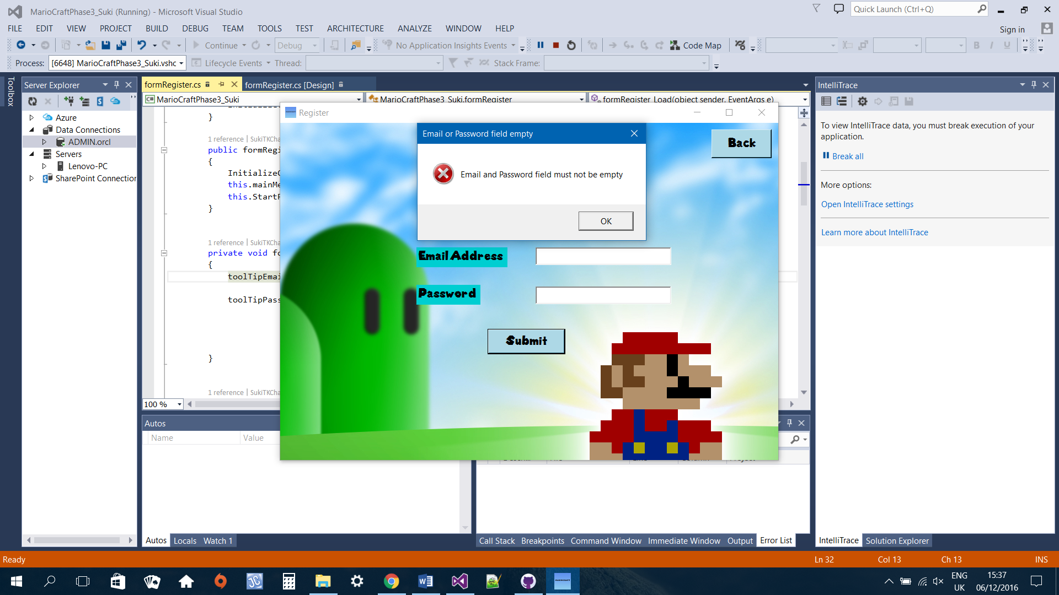

ToolTip

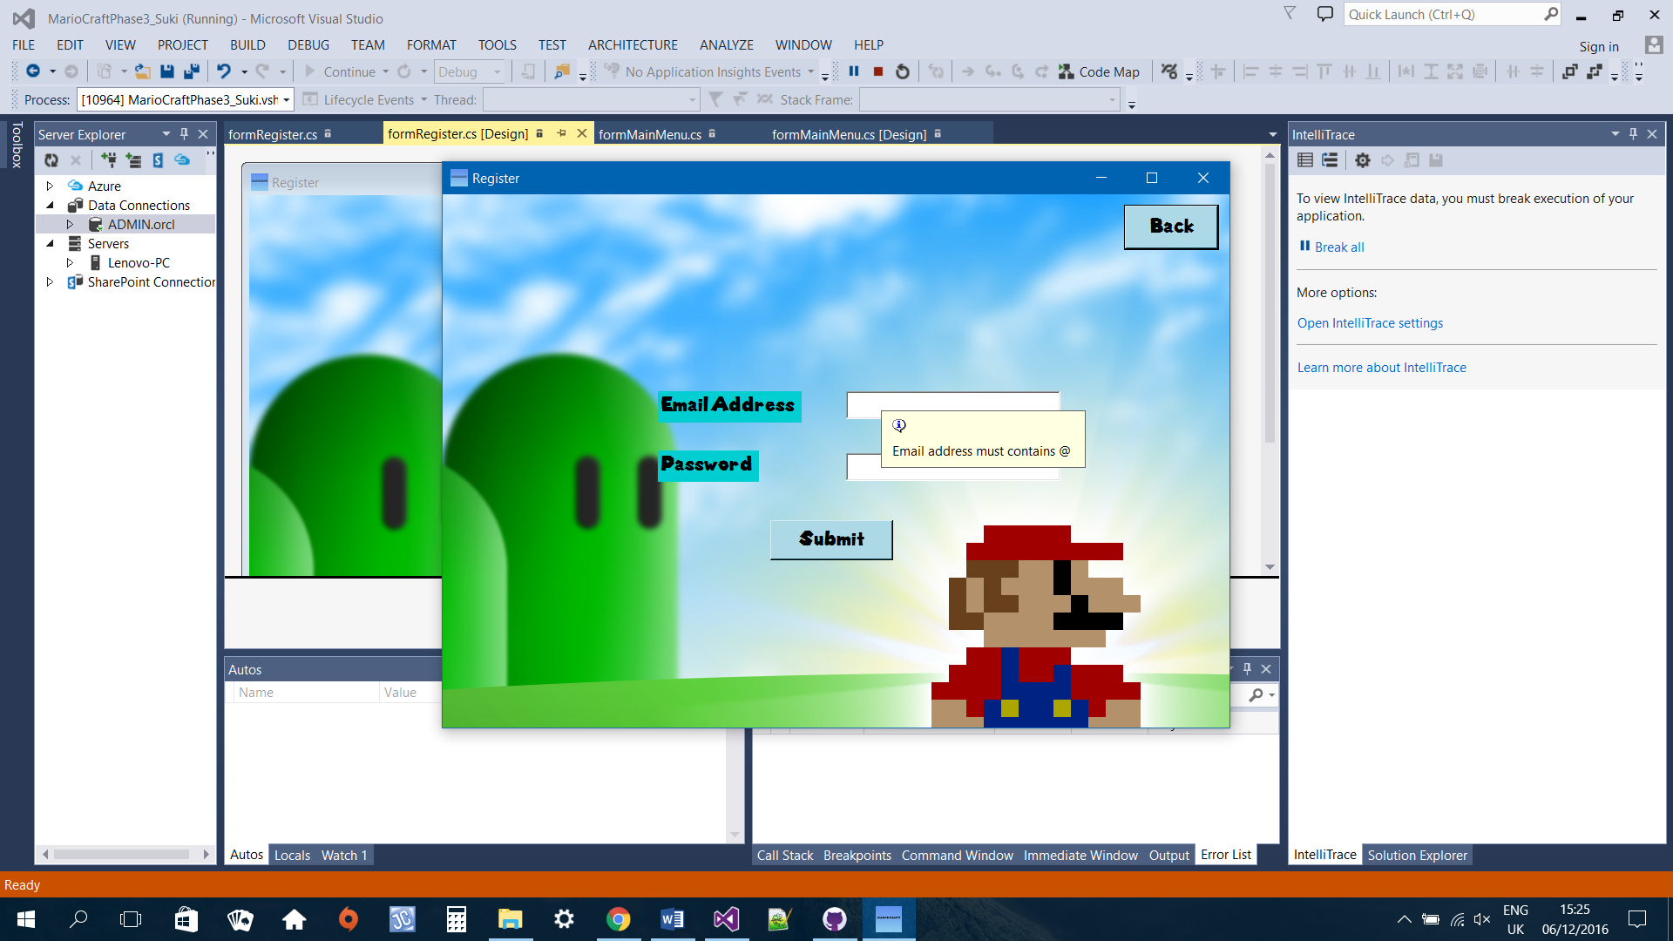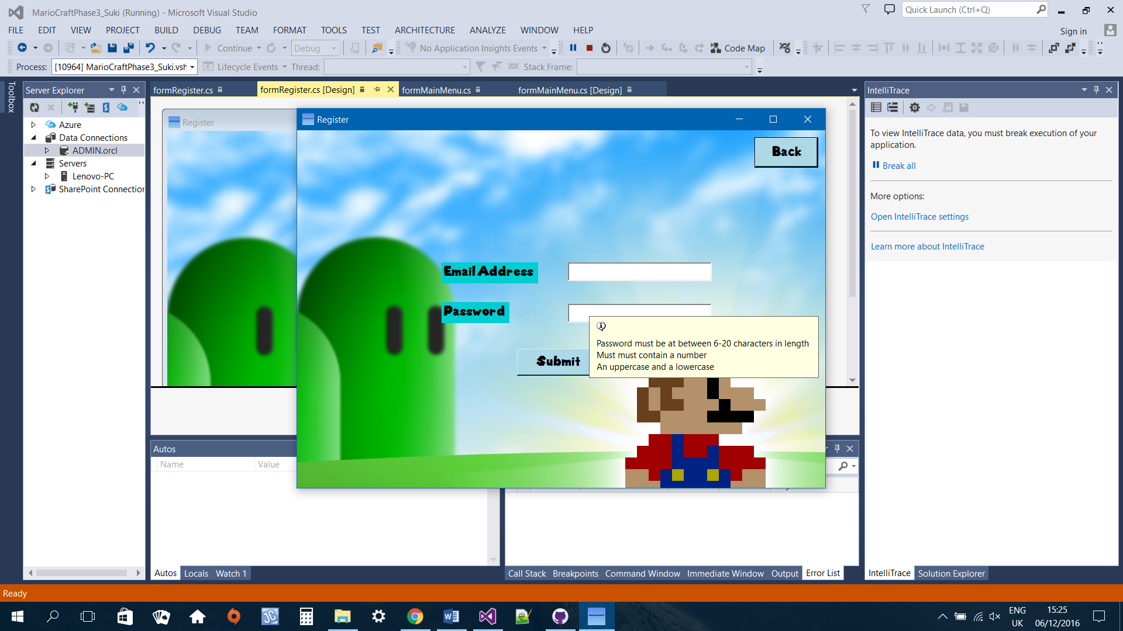

When registration success

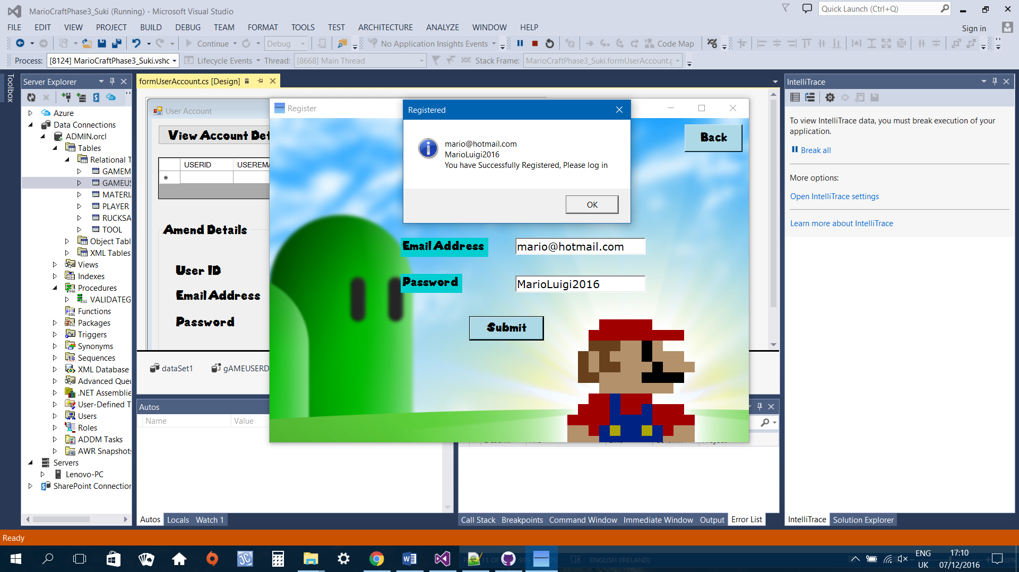

# **User Account**

The user account form allows registered game user to view their account details such as email and password. They can also amend those details. After the game user successfully log in, their user account window will display. When game user clicks on the view account detail button, a grid showing their user id and email will display. If they want to amend the details, they can click on the grid, their details will be loaded into the textboxes. They can then amend and update their details.

## **formUserAccount Code**

using System;

using System.Collections.Generic;

using System.ComponentModel;

using System.Data;

using System.Drawing;

using System.Linq;

using System.Text;

using System.Threading.Tasks;

using System.Windows.Forms;

namespace MarioCraftPhase3_Suki

{

public partial class formUserAccount : Form

{

MarioCraftModel ctx = new MarioCraftModel();

private formMainMenu mainMenu;

GAMEUSER gu = new GAMEUSER();

GAMEUSERDETAIL u = new GAMEUSERDETAIL();

private String email;

public formUserAccount()

{

InitializeComponent();

}

public formUserAccount(String email)

{

InitializeComponent();

this.email = email;

}

public formUserAccount(formMainMenu mainMenu)

{

InitializeComponent();

this.mainMenu = mainMenu;

this.StartPosition = FormStartPosition.CenterScreen;

}

private void btnUserDetail_Click(object sender, EventArgs e)

{

/*MarioCraftModel ctx = new MarioCraftModel();

GAMEUSER viewUser = new GAMEUSER();

var user = from u in ctx.GAMEUSERs where u.USERID == 73 select u;

this.txtEmail.Text = user.FirstOrDefault().USEREMAIL;*/

//this show current login user details

this.gAMEUSERDETAILSTableAdapter.FillBy(dataSet1.GAMEUSERDETAILS, email.Trim());

grdDetails.Show();

}

private void btnBackToMainMenu_Click(object sender, EventArgs e)

{

formMainMenu mainMenu = new formMainMenu(this);

this.Close();

mainMenu.Show();

}

private void formGameScreen_Load(object sender, EventArgs e)

{

}

private void grdDetails_CellClick(object sender, DataGridViewCellEventArgs e)

{

grpAmend.Show();

//var userID = from u in ctx.GAMEUSERs where u.USERID == id select u;

var userEmail = from u in ctx.GAMEUSERs where u.USEREMAIL == email select u;

//var userPassword = from u in ctx.GAMEUSERs where u.USERPASSWORD == password select u;

//this.txtID.Text = userID.FirstOrDefault().USERID.ToString();

this.txtEmail.Text = userEmail.FirstOrDefault().USEREMAIL.Trim();

}

private void btnUpdate_Click(object sender, EventArgs e)

{

if(txtEmail.Text.Equals(""))

{

MessageBox.Show("Email field cannot be empty", "Email field empty",

MessageBoxButtons.OK, MessageBoxIcon.Error);

txtEmail.Focus();

return;

}

//if amended email already exist in db

var user = (from u in ctx.GAMEUSERs where u.USEREMAIL == email select u);

var emailExist = user.FirstOrDefault(a => a.USEREMAIL.Equals(txtEmail.Text));

//if amended email already exist in db

if (emailExist != null)

{

if (emailExist.USEREMAIL.Equals(txtEmail.Text))

{

MessageBox.Show("Email address has been used, please enter another one", "Email cannot be used",

MessageBoxButtons.OK, MessageBoxIcon.Error);

txtEmail.Focus();

return;

}

}

else

{

using (var context = new MarioCraftModel())

{

userUpdate.USEREMAIL = txtEmail.Text;

try//update new email

{

context.SaveChanges();

MessageBox.Show("Details updated", "Account Details updated",

MessageBoxButtons.OK, MessageBoxIcon.Information);

}

catch (Exception ex)

{

MessageBox.Show(ex.GetBaseException().ToString(), "Error", MessageBoxButtons.OK, MessageBoxIcon.Error);

}

}

}

}

}

}

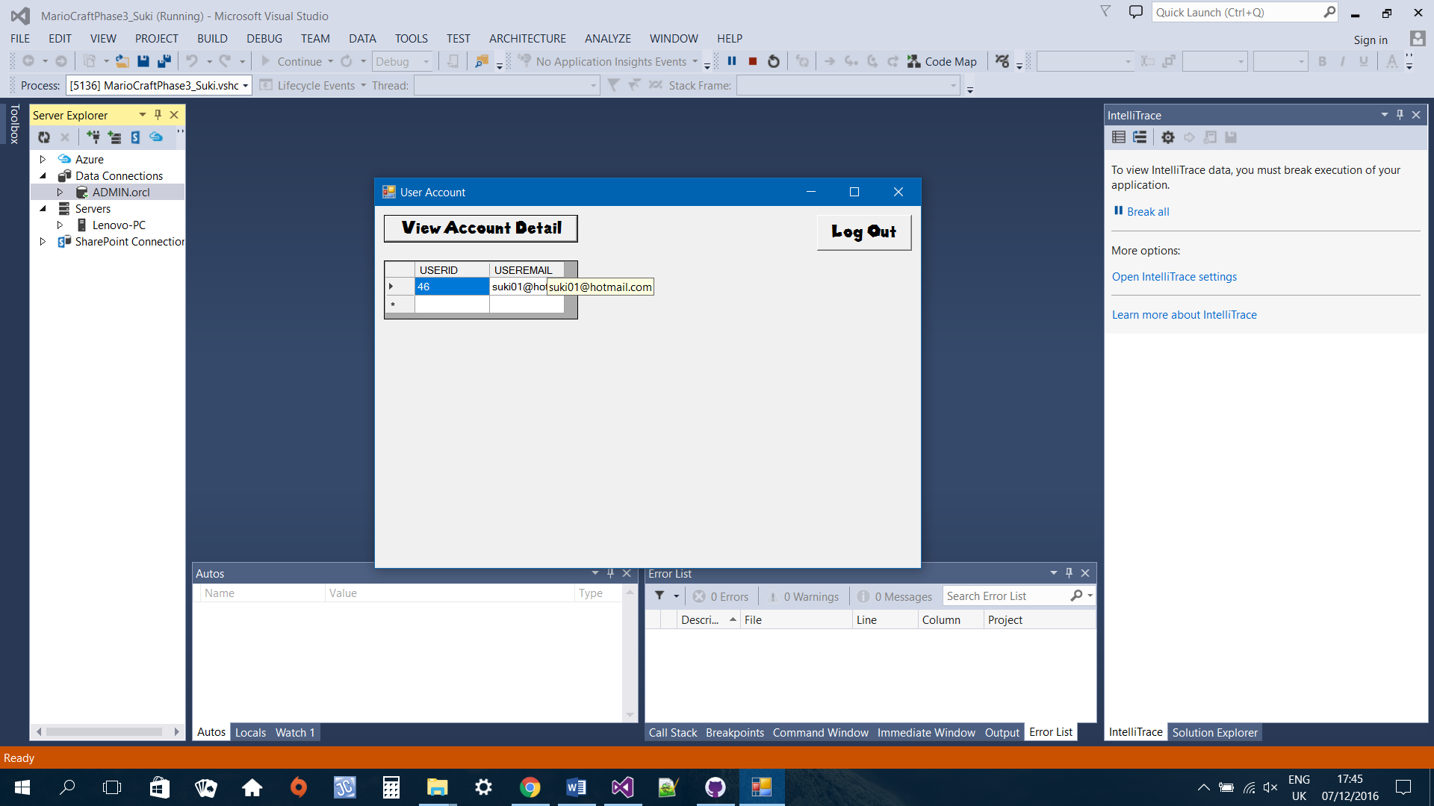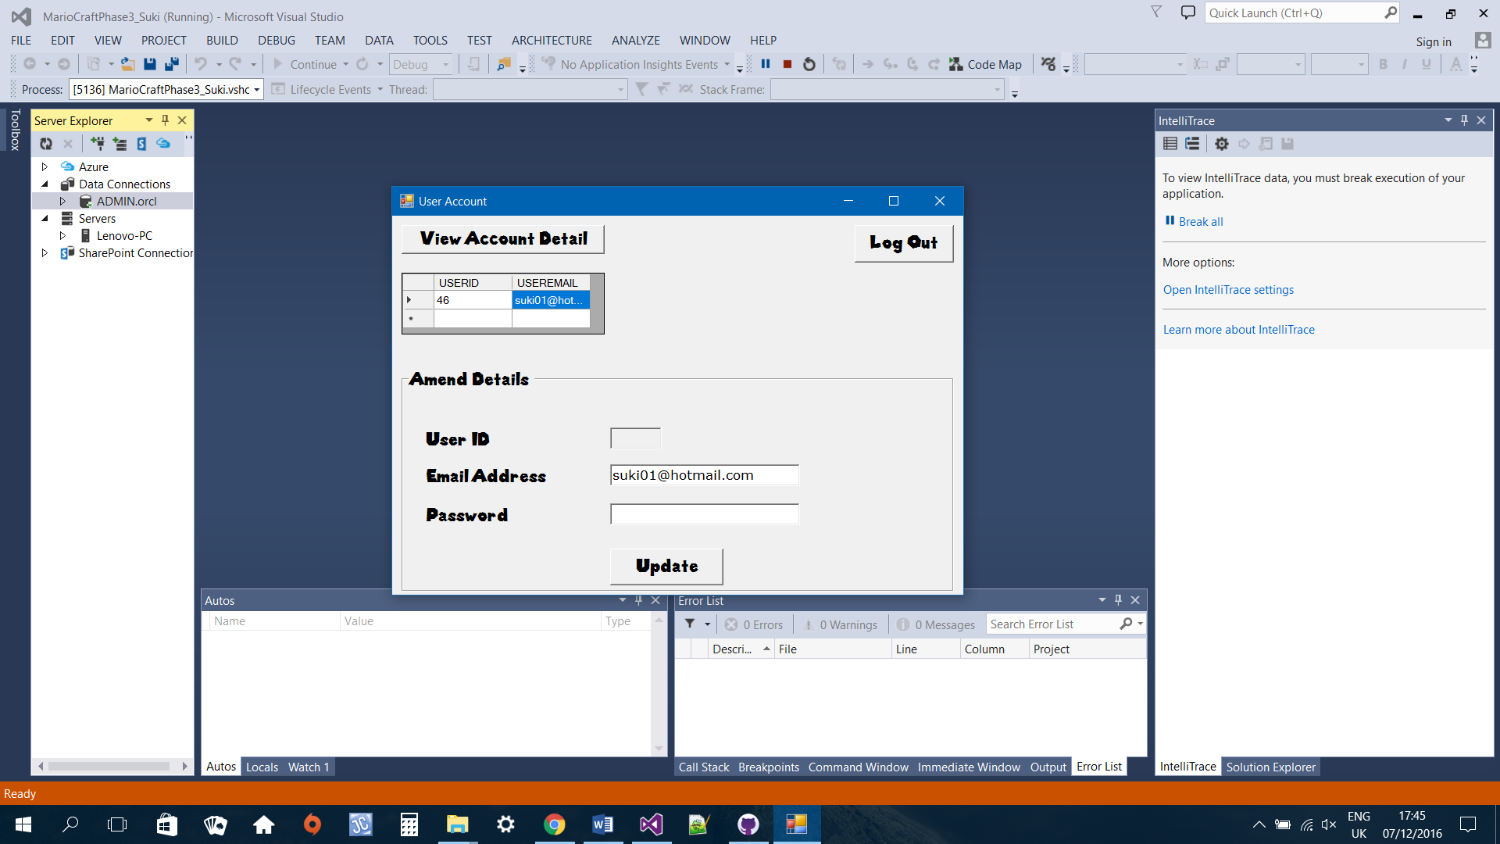

# **Conclusion**

I really enjoyed working on this phase of the project. I get to demonstrate what I have learned in class when creating this program. Even though this phase was to be complete individually, the team and I have meet up to discuss our progress and problems we encountered. They helped me with displaying the current game user’s login details. They also gave me feedback on the UI.

In this phase of the project, I have achieved the following:

* Creating a game user with validation
* Game user login with validation
* Display user

Problem that I encountered while working on this phase was problem with installing the entity framework. However, after searching for solutions on the internet and asking my fellow classmates for help, I was able to get the entity framework installed. The entity framework is really fast and straightforward.

If I were to do differently on this phase, I would write my own ADO layer instead of using the entity framework because I want to challenge myself.

# **References**

538Fonts, 2015. *Super Mario 286 font.* [Online]   
Available at: http://www.fontspace.com/category/mario  
[Accessed 06 12 2016].

Anon., n.d. *ErrorProvider.* [Online]   
Available at: https://www.dotnetperls.com/errorprovider  
[Accessed 01 11 2016].

Dotnet, V., 2012. *Entity Framework CRUD example with Stored Procedures.* [Online]   
Available at: https://www.youtube.com/watch?v=zuK6siUD3ow  
[Accessed 07 12 2016].

HD, i., 2012. *How to make a platform game in C# (#1) - Movements.* [Online]   
Available at: https://www.youtube.com/watch?v=Cc62S6b94QQ  
[Accessed 07 12 2016].

Info, P., 2016. *Super Mario Backgrounds.* [Online]   
Available at: http://www.pixelstalk.net/super-mario-backgrounds/  
[Accessed 06 12 2016].

Microsoft, n.d. *Create a simple data application by using ADO.NET.* [Online]   
Available at: https://msdn.microsoft.com/en-us/library/jj943772.aspx  
[Accessed 29 11 2016].

Microsoft, n.d. *Setting ToolTips for Controls on a Windows Form.* [Online]   
Available at: https://msdn.microsoft.com/en-us/library/aa984424(v=vs.71).aspx  
[Accessed 02 11 2016].

Oracle, n.d. *Getting Started with Oracle Data Provider for .NET(C# Version).* [Online]   
Available at: http://www.oracle.com/webfolder/technetwork/tutorials/obe/db/12c/r1/appdev/dotnet/GettingStartedNETVersion/index.html  
[Accessed 01 11 2016].

SeeSharpCode, 2015. *C# Entity Framework 6 | Database First | Part 1 - Basic CRUD.* [Online]   
Available at: https://www.youtube.com/watch?v=K4x6eoG7hwY  
[Accessed 07 12 2016].

theslayer29179, 2013. *Visual Studio C# Tutorial Part 3: Moving an object.* [Online]   
Available at: https://www.youtube.com/watch?v=2e-IJ1dAa28  
[Accessed 07 12 2016].

theslayer29179, 2013. *Visual Studio C# Tutorial Part 4: Moving With Keys.* [Online]   
Available at: https://www.youtube.com/watch?v=blBcGY_Ca7Q  
[Accessed 07 12 2016].